create a class and with divide two numbers by using Scanner class.(z=a/b).without try catch

Create a class with single try multi catch blocks.

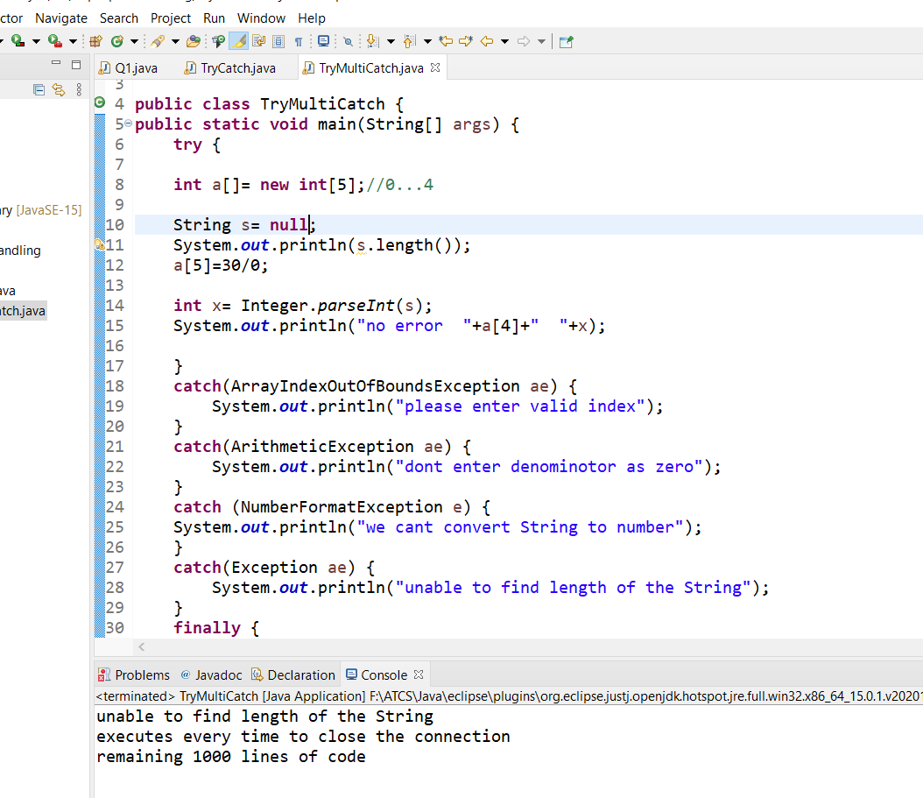

create a class with user defined exceptions.

create a class with Marks, and valid Marks method, give some number marks are less than he/she fails otherwise pass by using throw keyword.

